**ASG taks + Revision.**

**1) Create one vpc in N.virginia region.**

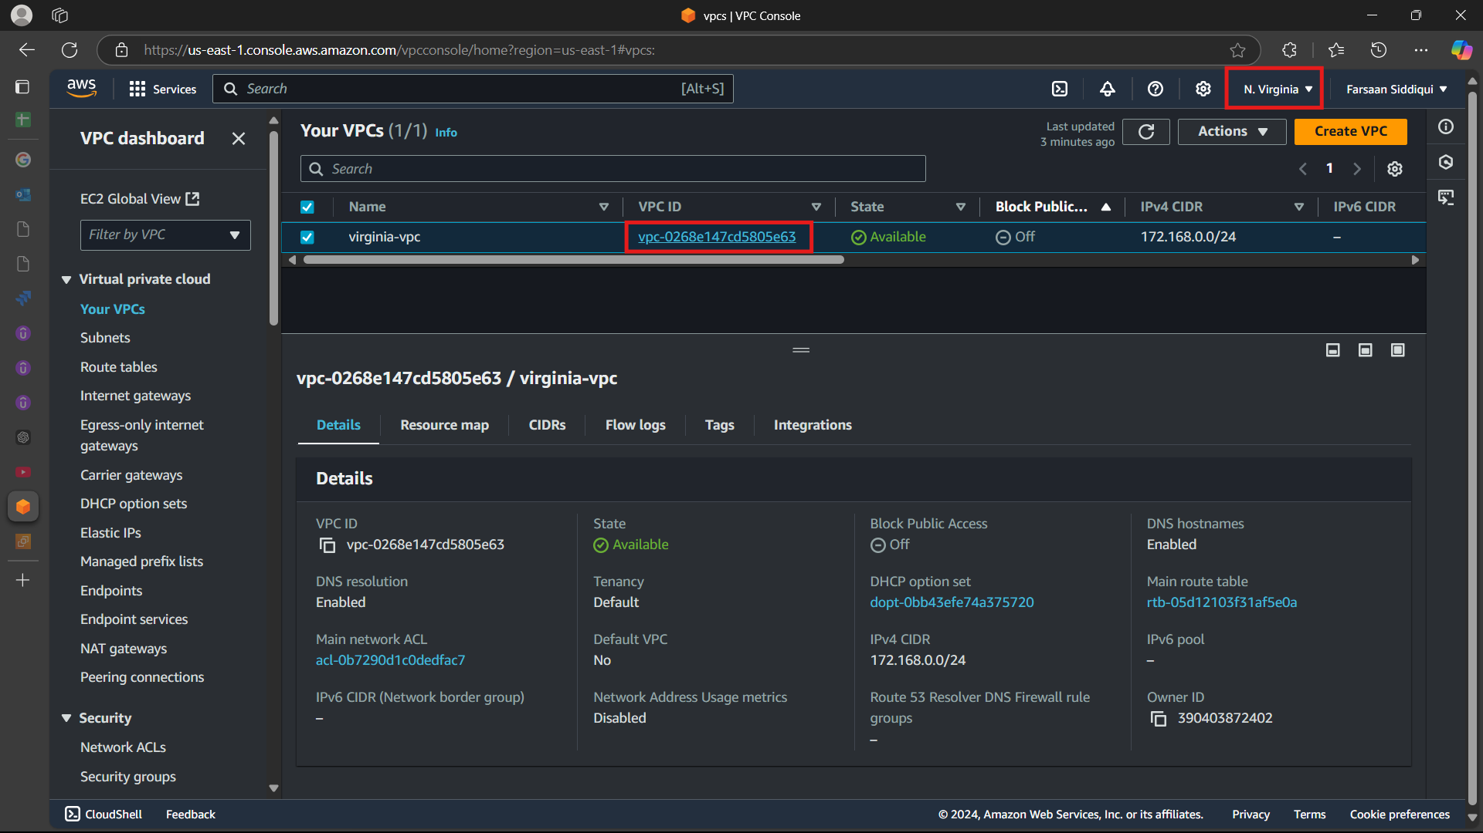

**2) Create One Public subnet and one private subnet.**

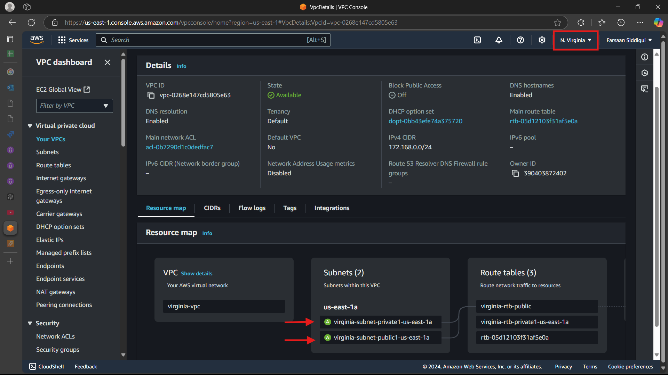

**3) Provide the IGW to the vpc.**

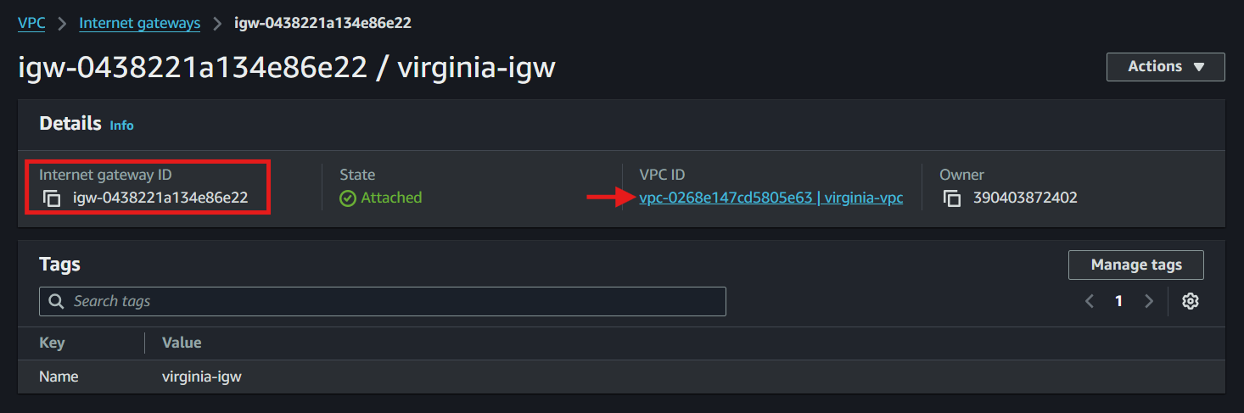

**4) Create One public RT and one private RT.**

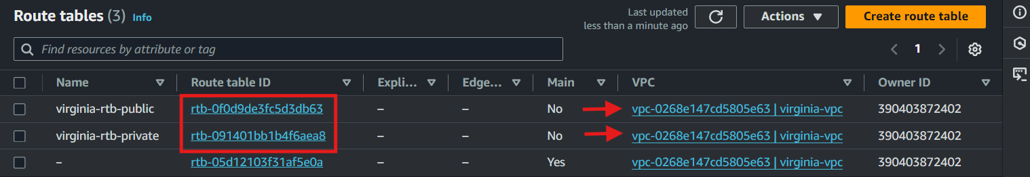

**5) Deploy NAT gateway on public subnet and attach the NAT gatewat to private subnet.**

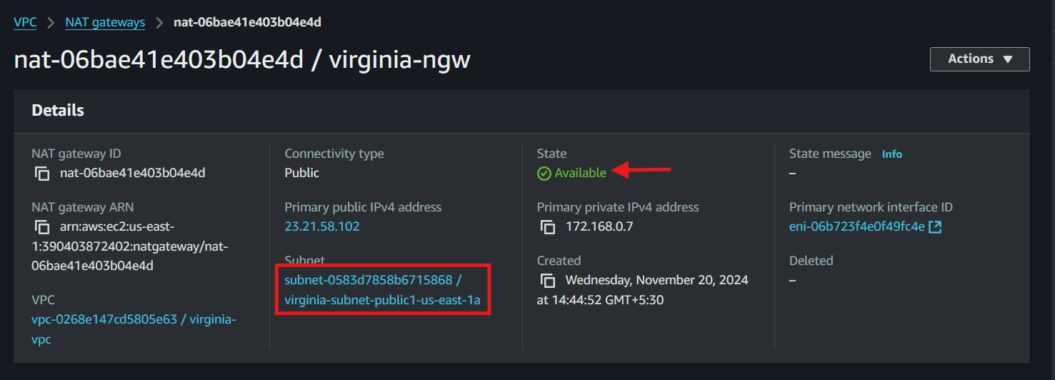

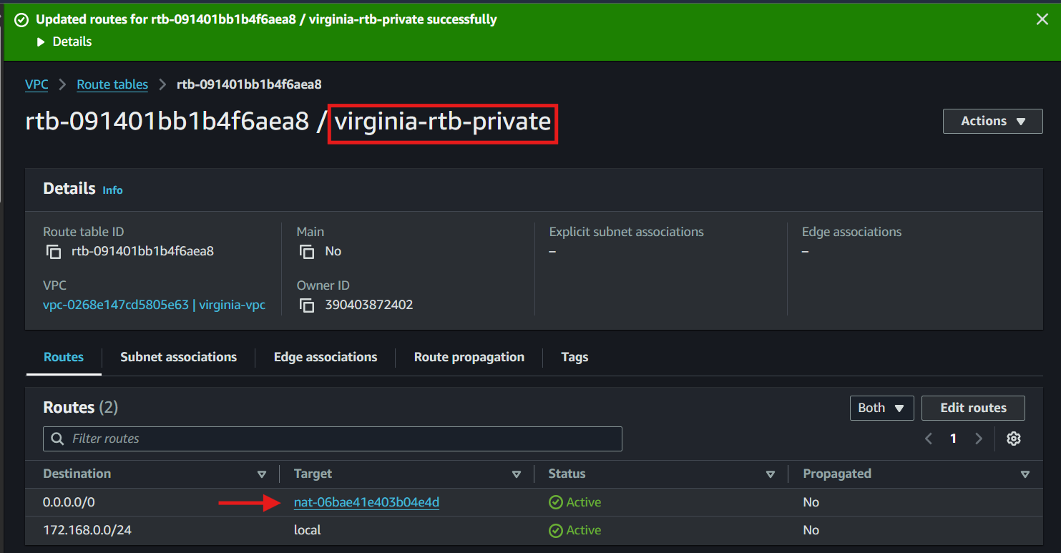

**6) Create Two instances,one in public subnet and one in private subnet.**

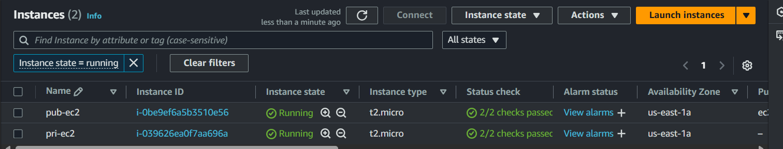

**7) Deploy Apache server on both the ec2 instances with sample index.html file.**

**\***public ec2



**\***private ec2

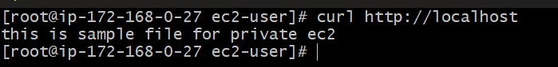

**8) Create one application load balancer and attach the load balancer to both the ec2 instances.**

**\***create a target group and target the instances you want to attach to load balancer

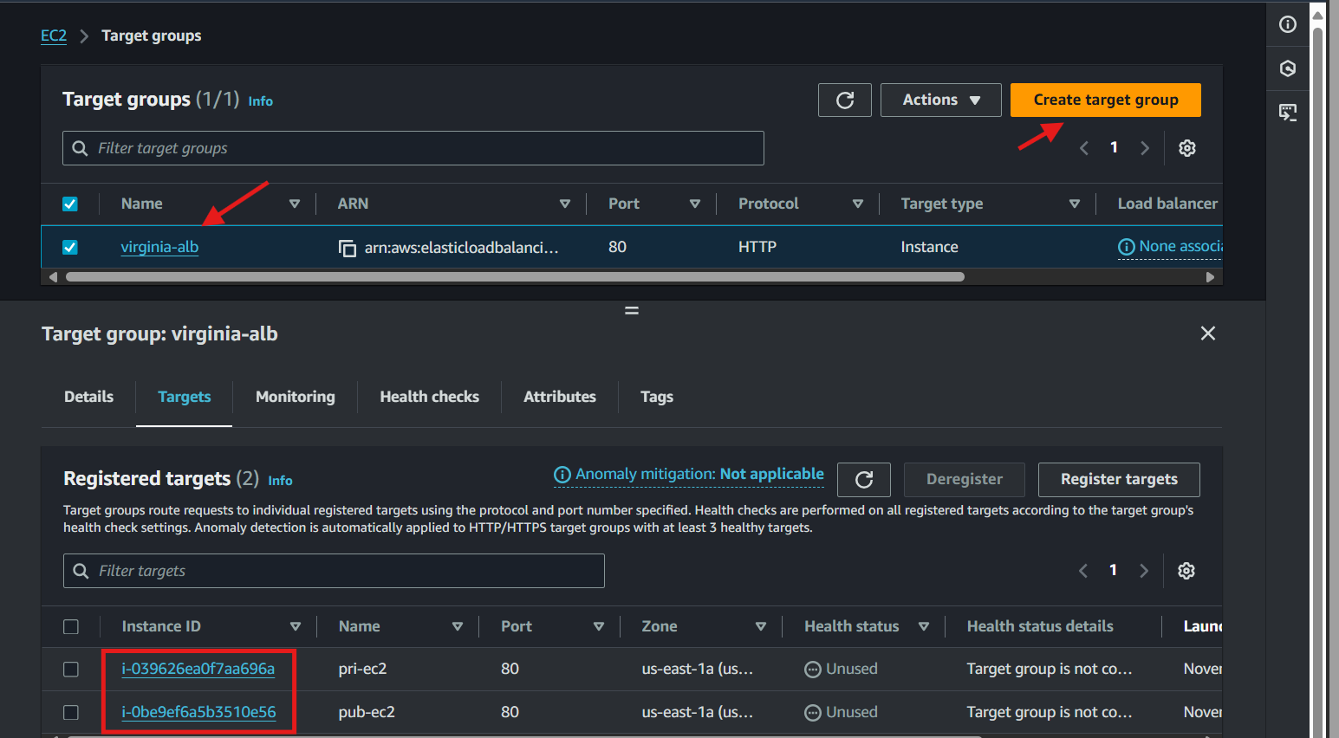

**\***create load balancer by selcting vpc and subnets and add target group created before

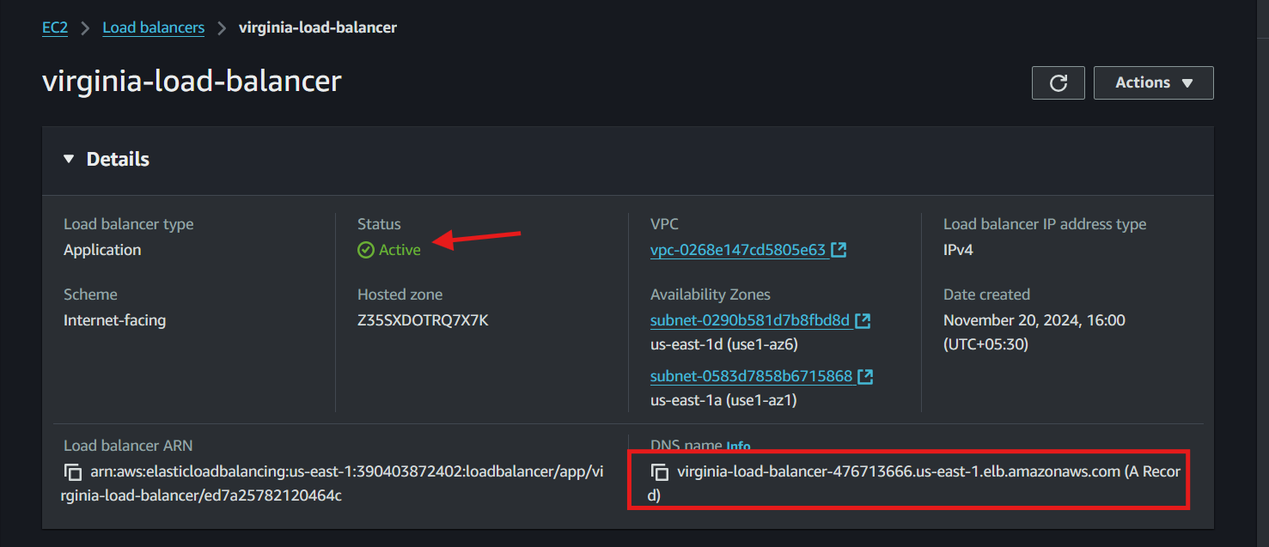

**\***test it with the load balancer dns name it will show the sample file created in task 7

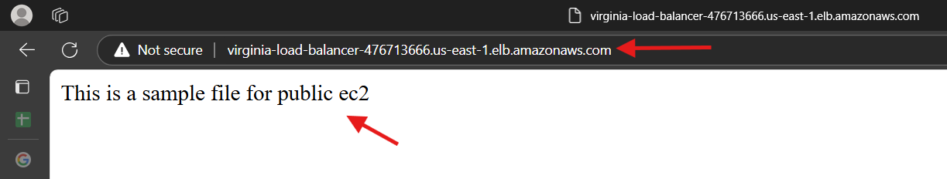

**9) Store Application load balancer logs to s3.**

**10) Store the vpc flow logs to cloudwtach group.**

**11) Create Monitoring Dashboards to monitor cpu utilization and to monitor apache service.**

**12) CPU utilizationis more than 70% then it should triggere Autoscaling and launch new instance.**